Ancient Arts Holistic Veterinary Services, PLLC
PLEASE PRINT LEGIBLY
Return completed form to clinic one week prior to appt. via fax 206-547-1325 or email ancientartsvet@gmail.com
If you arrive without completed paperwork, the time taken to fill out the forms will take away from doctor time.

Name of Human Guardian(s) & Preferred Pronouns:
Click here to enter text.
Home & Mailing Address (if different): Click here to enter text.
City/State/Zip: Click here to enter text.
Main Phone Number: Click here to enter text. Secondary Number: Click here to enter text.
Email Address: Click here to enter text.
Emergency Contact Name & Number: Click here to enter text.

Pet’s Name: Click here to enter text. Breed: Click here to enter text.
Age & Date of Birth: Click here to enter text. Sex: M☐ F ☐ Spayed/Neutered: Yes☐ No☐
Color/Markings: Click here to enter text.
Approximate Weight: Click here to enter text.

Describe any recent changes in:
Weight: Click here to enter text. Mood: Click here to enter text.
Thirst: Click here to enter text. Appetite: Click here to enter text.
Urination: Click here to enter text. Defecation: Click here to enter text.

Have there been any signs of: (check if true)
Regurgitation☐ | Diarrhea☐ | Constipation ☐| Incontinence ☐

Today’s visit is to treat: Click here to enter text.
Specify your goals for treatment: Click here to enter text.
When & where did you get your pet? Click here to enter text.

Is your pet aggressive toward: (check if true)
Dogs☐ | Cats ☐| Animals☐ | Men ☐| Women ☐| Kids ☐

Has your pet ever required sedation for any routine procedure? (i.e. dental cleaning, toenail trim, etc.) Click here to enter text.
Have there been any significant medical issues in the past? (i.e. surgeries, accidents, vaccine reactions, noise phobias (e.g. vacuum), separation anxiety, etc.) Click here to enter text.
Last vaccines given: Click here to enter text.
Frequency and types of vaccines and dewormings/fecals given to pet throughout lifetime: Click here to enter text.
Flea control, type & frequency: Click here to enter text.
What kind of food does your pet get? Click here to enter text.
Supplements? Click here to enter text.
Treats? Click here to enter text.
List all medications and dosages: Click here to enter text.
Are you capable of giving medication to your pet in the form of: (check if true)
Pills☐ | Liquids☐ | Powders in Food ☐
Exercise type & frequency: Click here to enter text.
Playtime type & frequency: Click here to enter text.
Has your pet traveled/lived outside of this area? (List where, when, & for how long)
Click here to enter text.
Are there other pets in the house? Click here to enter text.
Click here to enter text.
Do all your pets get along or are there conflicts? Click here to enter text.
Click here to enter text.
Is anyone in the house having similar symptoms or significant illness? Click here to enter text.
Have there been any changes in the household recently? Click here to enter text.
How did you learn about Ancient Arts? Click here to enter text.
Primary Care Veterinarian & Clinic: Click here to enter text.

Please click the boxes on the diagram below where you are noticing lameness or soreness or where lumps/masses are present on your pet.
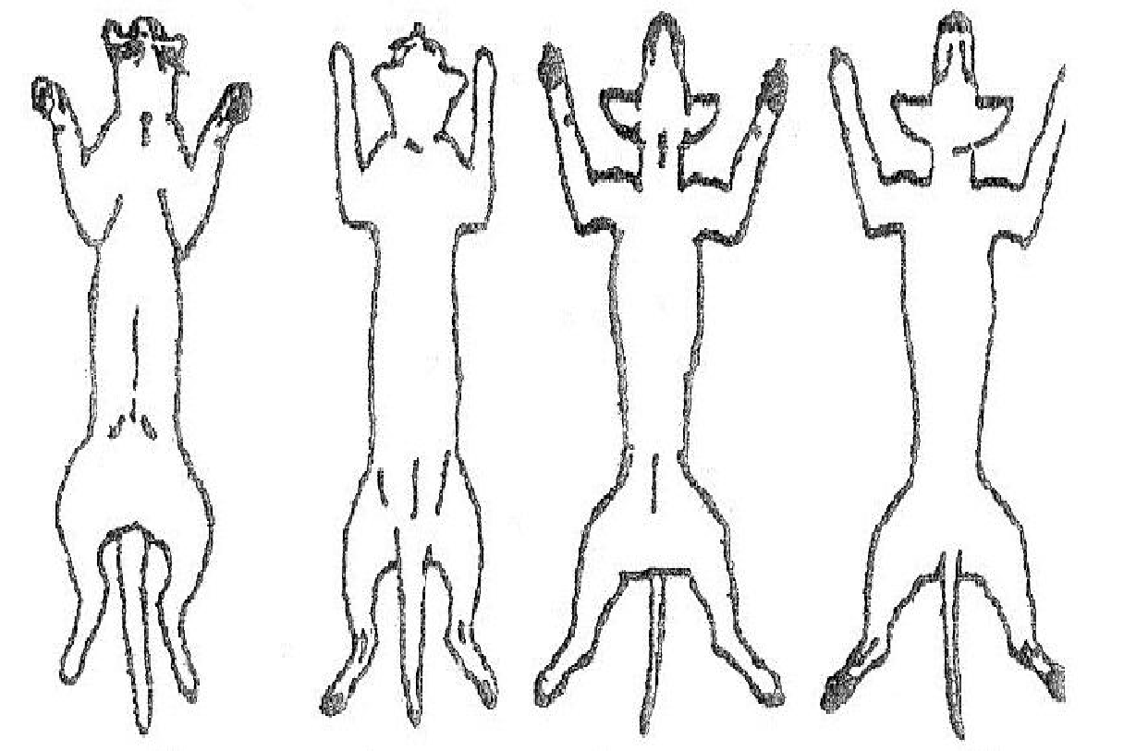
☐ ☐ ☐ ☐ ☐ ☐

☐ ☐ ☐ ☐ ☐ ☐
☐ ☐
☐ ☐
☐ ☐ ☐ ☐
☐ ☐ ☐ ☐ ☐ ☐
Underside Backside
Please initial each paragraph once you have read, understood, and agreed to the terms:

Initial here I understand that Ancient Arts veterinarians are licensed veterinarians who focus their practice on alternative and holistic therapies including but not limited to: acupuncture, aquapuncture, herbs, flower essences, prolotherapy, nutrition/food therapy, routine lab work, NAET allergy elimination technique, homeopathy/homotoxicology, detoxification, aromatherapy, reiki, tui na massage, qi gong meditation, energy work, and the understanding of the human-animal bond.
(Bold or highlight all modalities listed that you are open to or would like to learn more about.)

Initial here I understand that Ancient Arts Veterinary Services, PLLC, currently does not offer surgery, dentistry, or radiographs but can provide a referral if these are needed or desired. I understand that alternative care is not a substitute but is a complement to routine veterinary care, including dental care. I understand that my own participation is essential in helping my pet. This includes but is not limited to providing appropriate social, psychological, hygienic, physical, emotional, spiritual, mental, and routine medical care for my pet, as well as myself. I understand and am open to learning more about how my own energy affects that of my pet, and agree to conduct myself in such a way as to not disrupt the healing of my pet, or any other patients in the clinic (soft voices, no excessive/loud use of phone).
Initial here I understand that I am responsible for restraining my pet during acupuncture so that the needles are not pulled or shaken out. Please keep a harness or collar on your pet and keep them from hiding under or behind chairs.

Initial here I understand that Ancient Arts doctors always maintain their Hippocratic Oath to “above all else, do no harm” and work with the animals, not against them. This may mean that for some sensitive animals, subtle energetic techniques may be more appropriate than the use of acupuncture needles. Remember: each session is individual and may involve fewer or more needles or different treatment options than other sessions.

Initial here I will do my best to give 24-48 hrs’ notice for refills if I am not ordering them at a scheduled appointment.

Initial here I understand that Ancient Arts is not an emergency clinic nor should it be a substitute for urgent needs. Therefore, I agree to the email and phone policy to await up to 48 hrs for replies from staff and to only call OR email once for the same request within that time frame. I understand that questions not pertaining to the most recent/initial visit will warrant a new exam.

Initial here I understand that if my pet has incontinence or is a marker, he/she will need to wear a diaper or Belly Band to their visit to maintain hygiene and comfort for all patients, clients, and staff. I understand that if my pet shows signs of aggression or is difficult to handle the staff may request a muzzle, gentle leader, or additional tools to keep everyone safe and give my pet the best evaluation and care.

Initial here I understand that opened, mixed, or hand-counted supplements, herbs, and medications cannot be refunded.

Initial here I understand that Ancient Arts veterinarians always do their utmost best to heal patients and there is never a guarantee as to the outcome, as is true with all medicine and all aspects of life. I understand that if my pet is to receive long term herbs and/or supplements, a current doctor/patient relationship must be maintained by scheduling an exam at least once a year. New Issue/Have not seen the doctor in over a year needs a holistic exam. Recheck on an existing issue or seen the doctor within a year needs a recheck. Recheck on an existing issue and seen the doctor within six months needs a brief exam.

Initial here I understand that payment is due at the time of services rendered and that there is a $30 fee for any returned checks.

Initial here I understand that if I arrive more than 10 minutes late or if I do not show up to my scheduled appointment, and/or if I fail to give at least 24 hours’ notice for canceling or rescheduling an appointment, I will be charged a $50 fee for disregard of the doctor’s time and that of fellow clients who would have liked that appointment time slot.

Initial here If multiple No Shows or cancellations/reschedules have occurred with less than 24 hours’ notice, Ancient Arts Holistic Veterinary Services will require pre-payment for future appointments. These pre-paid appointments will have to be scheduled by phone during business hours or in person. (we will not accept pre-paid appointments by voicemail or online scheduling.) Not showing for a pre-paid appointment will result in forfeiture of pre-paid amount.

Signature: Click here to enter text. Date: Click here to enter text.

Print Name: Click here to enter text.

